EXPERIMENT NO. 1

Introduction of Simulator, design of AND,NOR,OR,NOT and NAND gates

SIMULATOR-A simulator is **a program or machine that simulates a real-life situation**, meaning that it creates a virtual version of it, often for the purpose of instruction or experiment, such as a flight simulator.

OR GATE-An OR gate is **a digital logic gate with two or more inputs and one output that performs logical disjunction**. The output of an OR gate is true when one or more of its inputs are true. If all of an OR gate's inputs are false, then the output of the OR gate is false.

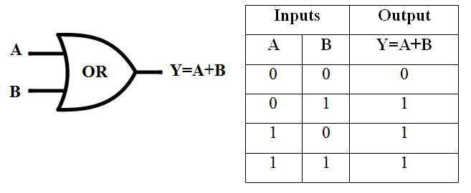

AND GATE-***n AND gate****has two or more inputs and one output, and if the inputs applied to it are all 1, then the output will be 1.*

***An AND gate****is an electrical circuit that combines two signals so that the output is on if both signals are present.*

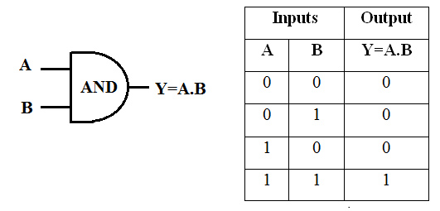

NOR GATE-A NOR gate is **a logic gate which gives a positive output only when both inputs are negative**. Like NAND gates, NOR gates are so-called "universal gates" that can be combined to form any other kind of logic gate.

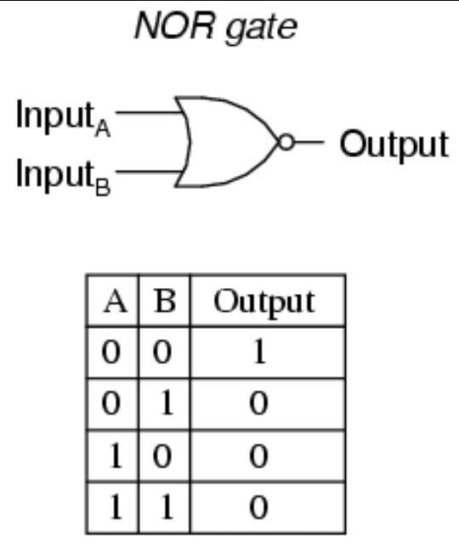

NOT GATE-A NOT gate **uses just one input to generate one output**. A NOT gate inverts the input - the output is 1 (TRUE) if the input is 0 (FALSE), and the output is 0 (FALSE) if the input is 1 (TRUE). The NOT gate has what appears to be a nose at the front.

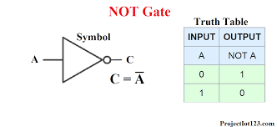

NAND GATE-In digital electronics, a NAND gate (NOT-AND) is **a logic gate which produces an output which is false only if all its inputs are true**; thus its output is complement to that of an AND gate. A LOW (0) output results only if all the inputs to the gate are HIGH (1); if any input is LOW (0), a HIGH (1) output results.

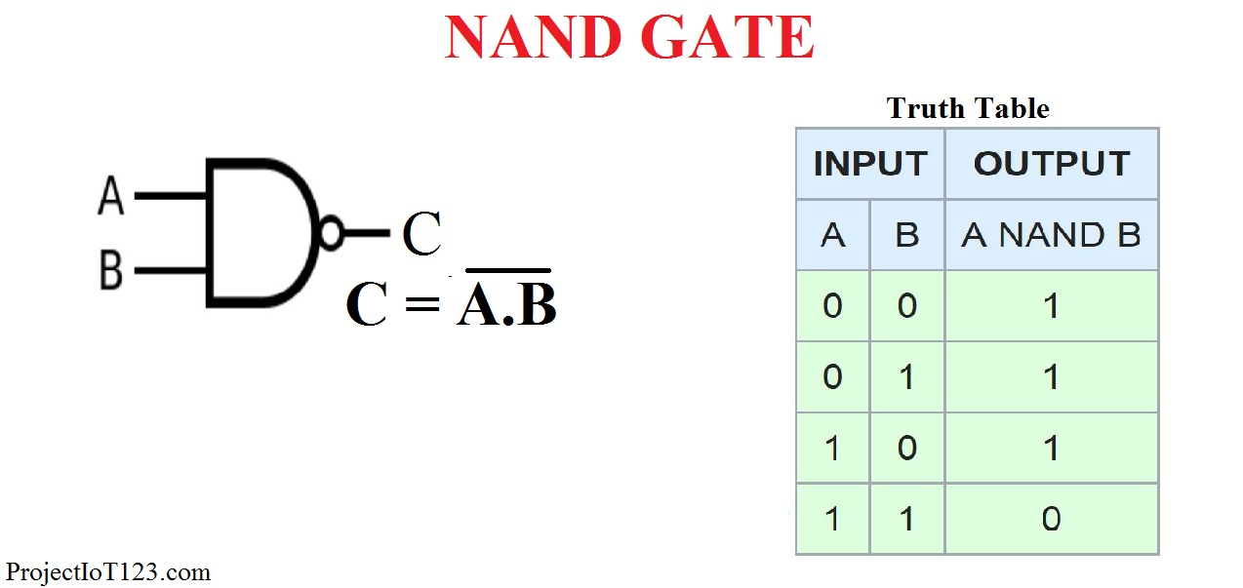

OUTPUT …………………………

OR GATE(2 inputs)

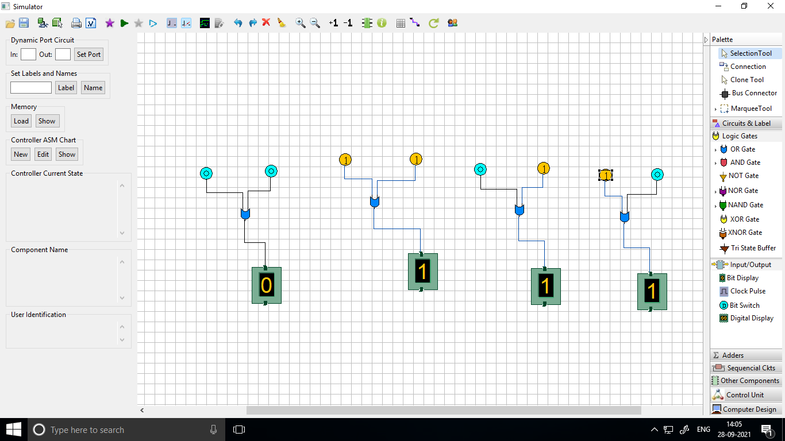

OR GATE(3 inputs)

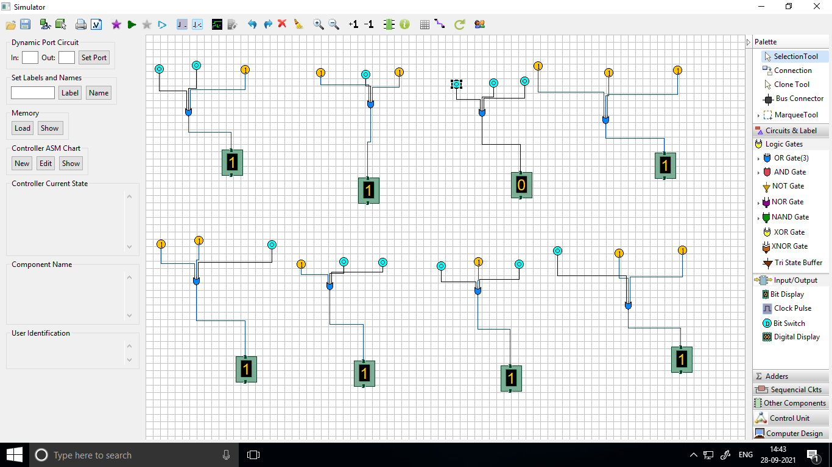

AND GATE(2 INPUTS)

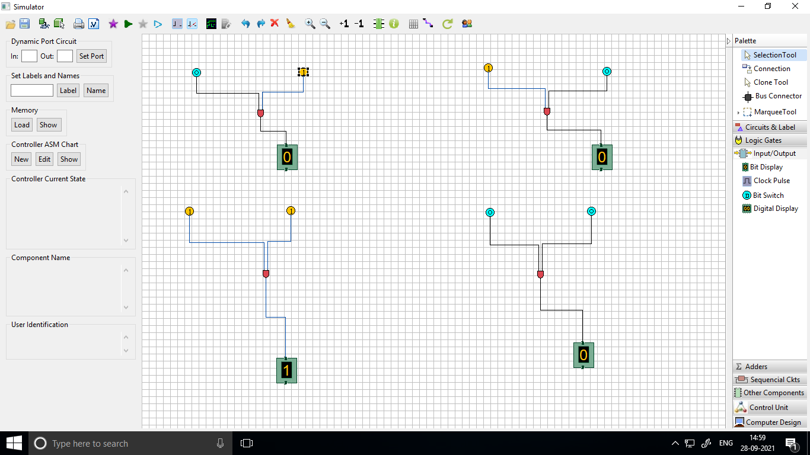

AND GATE(3 INPUTS)

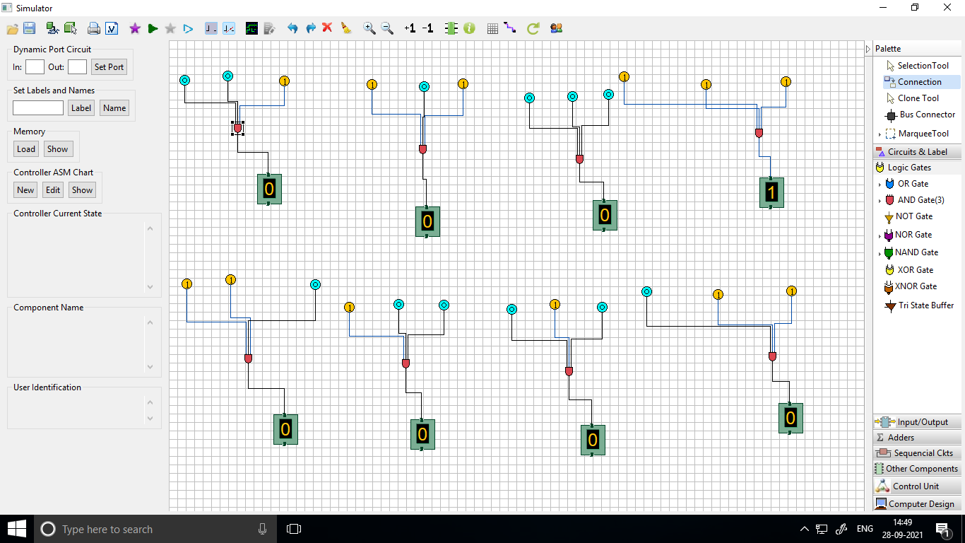

NOT GATE

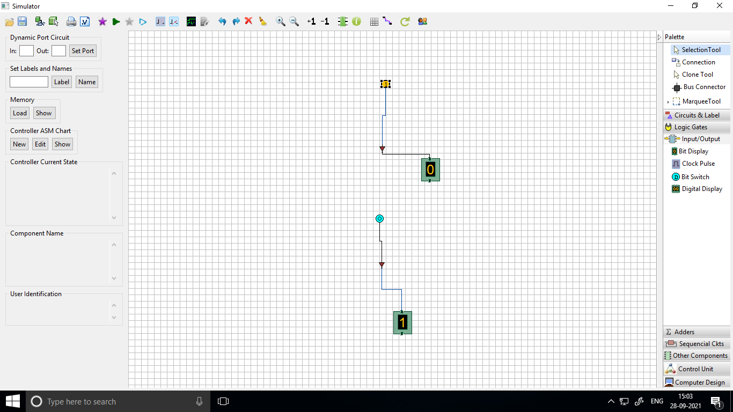

NOR GATE(2 INPUTS)

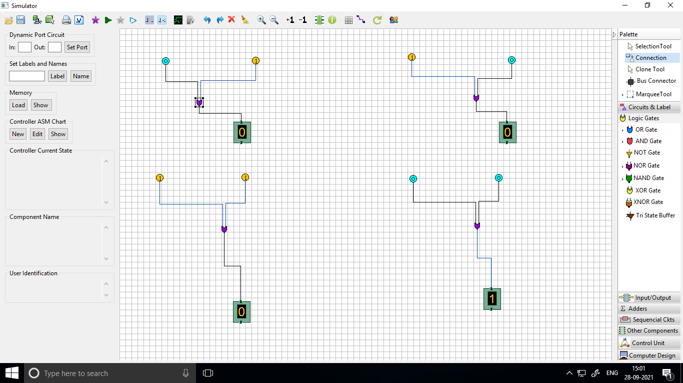

NOR GATE(3 INPUTS)

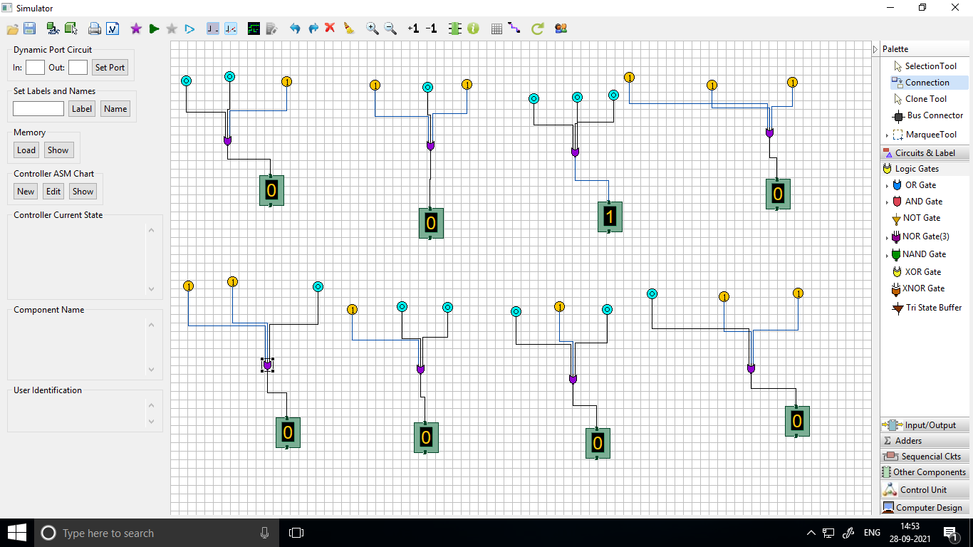

NAND GATE(2 INPUT)

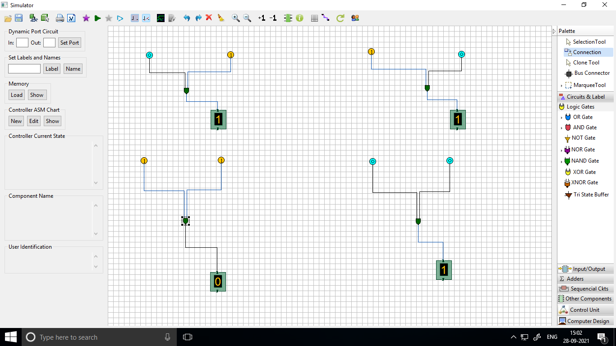

NAND GATE (3 INPUTS)

